|  |
| --- |
| 新东方在线英语学习 |
| 新概念 1 册 |
| Lesson83-84 |



扫一扫。更多有趣的英语资讯。

1. mess: n.杂乱，凌乱It’s very untidy.

Excuse the mess.

1. pack: v.包装，打包，装箱pack the books into the case
2. suitcase: n.手提箱4.leave: v.离开

left- left

He left yesterday. 5.already: adv.已经

1. I’ve already had lunch.

# Lesson 83 单词讲解

**Lesson 83 课文讲解**

I had lunch at half past twelve. already

已经，放在肯定句、疑问句中位置：通常在 done 前

他已经洗完澡了。

He has already had a bath.

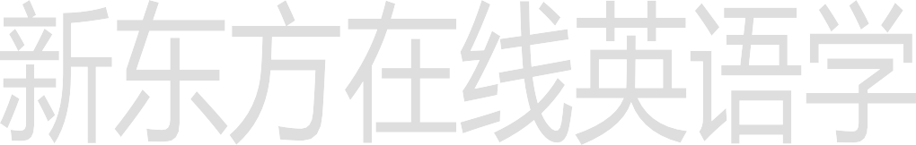

我已经上完课了。

I have already had my lesson.

你已经完成作业了吗？

Have you already done your homework?

他已经游完泳了吗？

Has he already had a swim?

1. Have a cup of coffee then. then
   1. 然后
   2. 那么

Then no.

那就算了。

* 1. I’ve just had a cup.

I had one after my lunch. just

刚刚，放在肯定句中

位置: 通常在 have\has 后他刚刚洗完澡。

He has just had a bath.

我刚刚上完课。

I have just had my lesson.

* 1. Aren’t you lucky! You are so lucky！

# Lesson 83 语法讲解

**主语 + has\have + done**

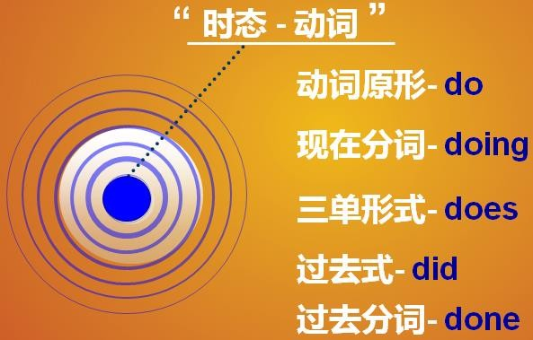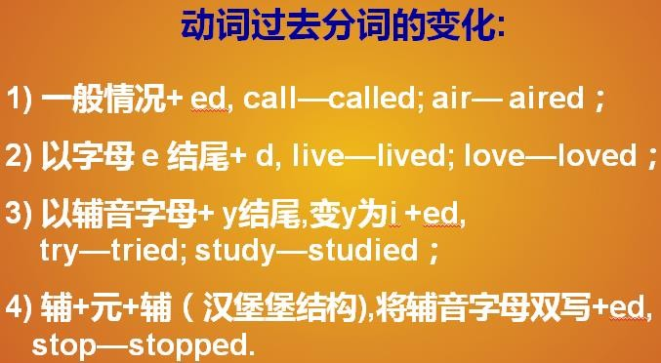

我已经给房间通过风了。

I have aired the room.

他已经看完这部电影了。He has watched the movie. 我们已经到达北京了。We have arrived in Beijing. 我已经吃过早饭了**。**

I have had breakfast.

他已经度过假了。 He has had his holiday. 她已经理过发了。She has had a haircut. 疑问句：

have\ has 提前否 定 句 ： have\ has + not

你已经给房间通过风了吗？

Have you aired the room?

他已经看完这部电影了吗？ Has he watched the movie? 我们已经到达北京了吗？ Have we arrived in Beijing? 你已经吃过早饭了吗？

他已经度过假了吗？ Has he had his holiday? 她已经理过发了吗？ Has she had a haircut?



你没有给房间通过风。 You have not aired the room. 他没有看完这部电影了。

He has not watched the movie.

我们没有到达北京。

We have not arrived in Beijing.

Have you had…?

# 西方的节假日

New Year’s Day 新年

# Lesson 84 单词句型讲解

**Lesson 83&84 知识拓展**

Valentine’s Day 情人节（Feb.14th ）

Easter Day 复活节

(the first Sunday after the full moon following the spring equinox ) April Fool’s Day 愚人节（Apr.1st ）

Halloween 万圣节 (Nov. 1st ) Thanks giving Day 感恩节

（the last Thursday of Nov.）

